CPIT Department of Computing

CH3866 Bachelor of Information and Communication Technologies

CH3880 Graduate Diploma in ICT

BCIT242 Web Site Development

CPIT Primary RGB.tifAssignment One

Semester One 2015

Due date: Part A Friday 8th May 2015 at 4.00pm

Part B Friday 12th June 2015 at 4.00pm

**SECTION TOPIC MARKS**

A Web site specification 100

B Web site implementation 100

**TOTAL MARKS: 200**

Student Name/ID: Nicholas King, William Cameron, Christina Ling

*CPIT and its division members reserve the right to use electronic means to detect and help prevent plagiarism. Students agree that when submitting this assignment, it may be subject to submission for textual similarity review to Turnitin.com.*

Submissions received late will be subject to a penalty of 10% of the student’s mark per working day.

Assessment One Part A is worth 20% and Assessment One Part B

is worth 30% of the total marks for this course.

This paper has five (5) pages including the cover sheet.

Project Name: Korean Esports

# Goals

1. To introduce the user to Korean Esports through having a variety of information on the subject that is displayed on the website. It will be easy to navigate and have a user friendly design that is easy to grasp.
2. To educate the user on the many Esports games, teams, players and tournaments that are in Korean, through text, video and images.
3. To get the user interested in Korean Esports through showing how Esports is viewed treated differently in Korea by showing information about Korea’s Esports culture.

# Objectives

1. To increase the amount of people around the world watching and following Korean Esports by at least a couple hundred in 6 months.
2. To increase awareness of KT Rolster esports club by increasing their page hits by at least 25% in the first 4 months the site is active.
3. To increase the social media following Korean Esports have on their streams, Facebook and twitter in 4 months.

# Target Audience

The target audience for this website would be people who are interested in Korean Esports. This also counts toward anyone who is just curious or wants to learn more about Esports in general but with a focus on Korean Esports. This means that the target audiences demographic would be quite similar to that of esports, which most are male with a small percentage being female, between the ages of 13 – 40.

# Target Audience Personas

* ***Kang Chan-yong (강찬용)*** is in 11th Grade at Kyungnam High School, a school that is renowned for having one of the best high school teams in all of South Korea. He is interested in computers and plans to study something in I.T. when he graduates. One of his favorite things to do is go to PC bangs with friends after school and on weekends and play PC games such as StarCraft 2 and League of Legends. While at the start he was quite casual about playing with friends he has begun to play more seriously entering local tournaments and become better at the games. Through entering Local tournaments he has learned that there are “Professional Gamers” who play the games he does and get paid for it much like athletes in other sports.

Though he has never really been a big fan of any Sports he finds himself fascinated by the idea of esports. He begins to start watching any matches he can that are broadcast on TV and some that are streamed on PC. This leads to him looking for more information about different tournaments that are running, the teams that play in the tournaments and the star players who he looks up to.

* ***Tristan Schrage*** has just finished High School and has started his freshman year of his 3D Design degree at an Arts College. His hobbies include drawing, 3D design and gaming. He is athletic and enjoyed playing sports at high school due to his competitive nature. He is a big fan of League of Legends and has been playing it since he started High School. As he has started his degree he is finding that he just doesn’t have the time to play as much as he use too, but he has heard about their being pro leagues for League of Legends in Korea.

Fascinated that in Korean people can be paid to play video games he catches a broadcast of one of the tournaments that is streamed online. He’s amazed at the level of production and the amount of fans that are watching live that can range from a few hundred to tens of thousands not counting the hundreds of thousands watching the stream like him. He begins to start following the weekly broadcasts but finds himself not knowing all of the teams and players, frustrated at his ignorance he begins searching online for information about tournaments, teams and players.

# Timeline

* **Discovery/Planning**

Minutes / Hours estimated to be required: 240mins / 4 hrs

Date of estimated completion: 8th May 2015

* **Research**

Minutes / Hours estimated to be required: 300mins / 5 hrs

Date of estimated completion: 11th May 2015

* **Design**

Minutes / Hours estimated to be required: 300mins / 5 hrs

Date of estimated completion: 17th May 2015

* **Content Writing**

Minutes / Hours estimated to be required: 300mins / 5 hrs

Date of estimated completion: 20th May 2015

* **Multimedia**

Minutes / Hours estimated to be required: 180mins / 3 hrs

Date of estimated completion: 24th May 2015

* **JavaScript**

Minutes / Hours estimated to be required: 300 mins / 5 hrs

Date of estimated completion: 29th May 2015

* **Implementation**

Minutes / Hours estimated to be required: 600 mins / 10 hrs

Date of estimated completion: 7th June 2015

* **Beta Testing and review**

Minutes / Hours estimated to be required: 240mins / 4 hrs

Date of estimated completion: 10th June 2015

**Total hours estimated:** 41 Hours

**Total cost estimated:** If this was the real world and not an IT class we would be charging $120 per hour. So if the project goes by the plan above the total cost will be $4920.

Hosting Costs

1. **Hosting Option 1: Hostpapa**

*Starter Option ($1.00 per month, 2 websites, 100GB storage, Unlimited Bandwidth)*

Link: <http://www.hostpapa.co.nz/web-hosting-plan/>

1. **Hosting Option 2: Godaddy**

*Deluxe Option ($9.99 per month, unlimited websites, storage and bandwidth)*

Link: <https://nz.godaddy.com/hosting/web-hosting.aspx>

1. **Hosting Option 3: Webdrive**

*Starter Option ($15.00 per month, 1 website, 1GB storage, 5GB Bandwidth)*

Link: <http://www.webdrive.co.nz/web-hosting.php>

Domain Name Registration

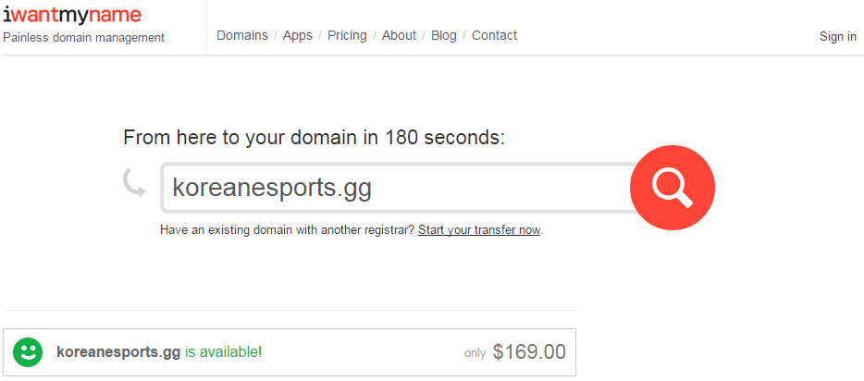Koreanesports.gg is the Domain we will use for our website.

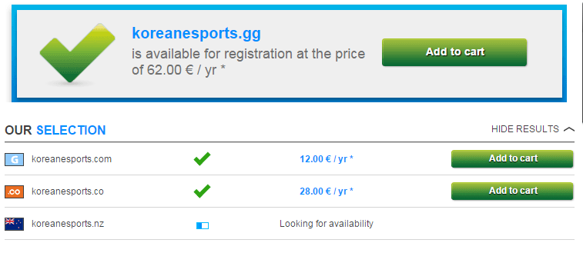(Source: iwantmyname.co.nz)

---------------------------------------------------------------------------------------------------------------------------

(Source: http://www.netim.com/)

---------------------------------------------------------------------------------------------------------------------------

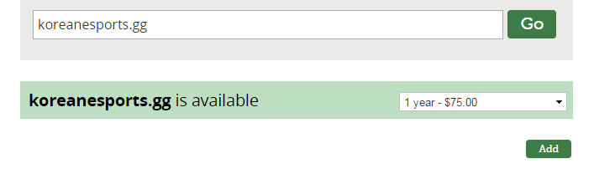(Source: www.gandi.net)

---------------------------------------------------------------------------------------------------------------------------

Site Map

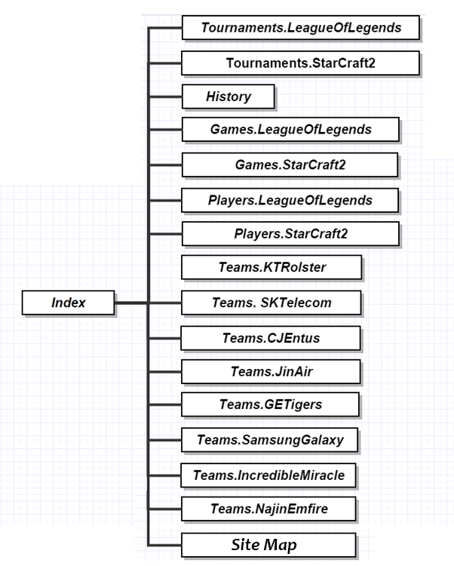

Page Design

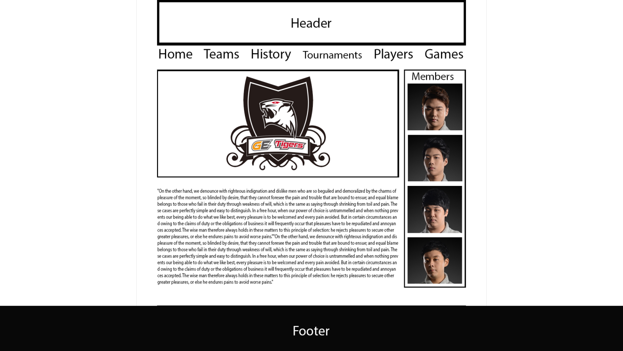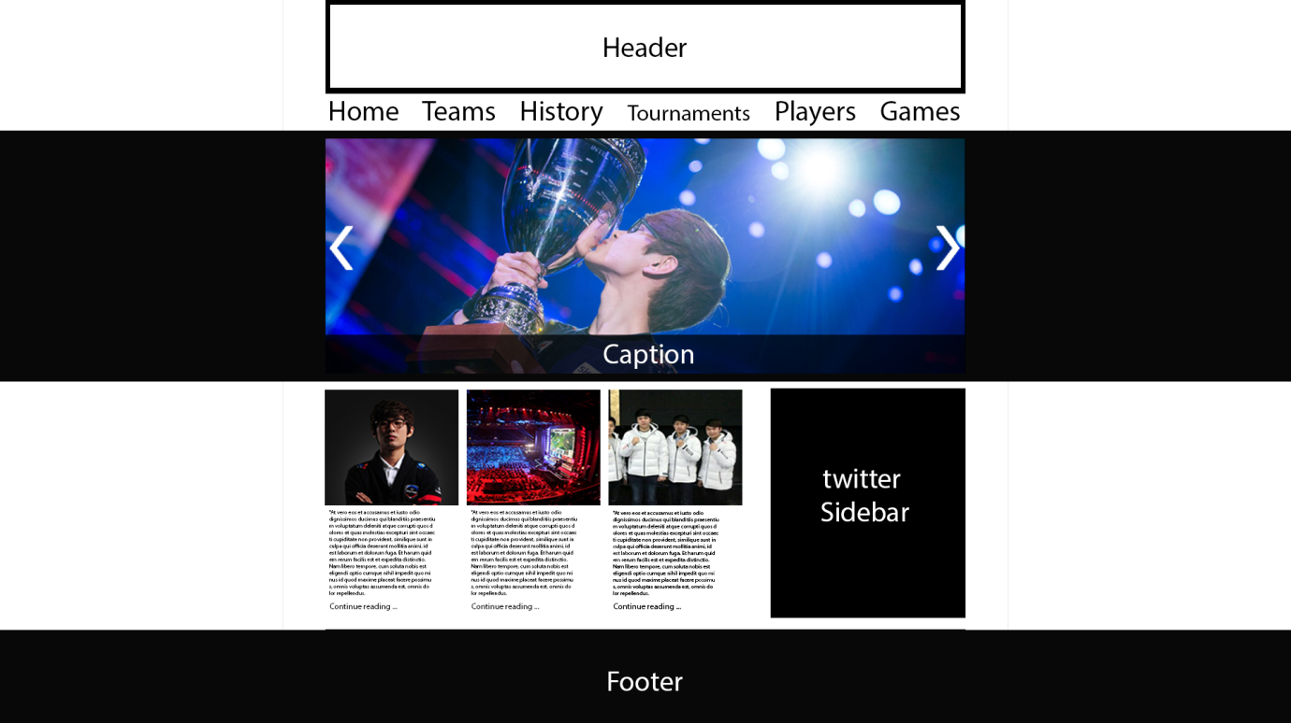

Search Engine Optimization

1. **Unique and accurate page titles**

<title> tag will be placed within the <head> tag, will also have unique title for each page of the website. Title created will accurately describe the page’s content and will avoid putting unnecessary keywords into the websites <title> tags.

1. **Use description meta tag**

Will write a description that will both inform and interest users if they saw it as a snippet in search results. Also will use different and unique descriptions for each page of the website.

1. **URLs will have structure**

URLs will use words that are relevant to the site’s content. Will avoid using long URLs with information useless to the user, generic pages names like “page1”.html and using excessive keywords.

1. **Site will be easy to Navigate**

Will make the site easy to go from general content to more specific content that the user might want. Will avoid creating complex navigation links e.g. linking every page to every other page on the website.

1. **Quality content and services**

Will use well written content that is easy to follow, also break content up into logical chucks so users can find content they want faster. Will avoid using sloppy written content that contains spelling and grammatical mistakes. Also will avoid having large amounts of text on a page without using proper formatting like split text into paragraphs and using titles for different topics on the same page.

1. **Optimize use of images**

Will use short and descriptive filenames and alt text for images used on the site. Will avoid using generic filenames such as “image1”.jpg, writing long filenames and putting unnecessary keywords into alt text.

1. **Site Map**

Will have an HTML site map page that links to all the most important pages on the website and gives an outline of the structure. Also creating a XML sitemap file that will help search engines discover the pages on the site. Will avoid letting site map page become out of date by making sure it contains no broken links.

Accessibility

Accessibility is to add features for disabled users, so they can use the site more comfortably. Some features we will add are:

* Alternative text descriptions for image tags so people using screen readers know what the image is showing.
* There are a large percentage of people with colour blindness, so we will use a colour pallet that should be able to be viewed by all. E.g. not a mix of red, green blue. Make a pallet from the same spectrum.
* Some people may only have a keyboard, or hovering over a navigation button may not work on their touch screen, so adding a site map so they can explore by arrow keys taking them to the correct hyperlinks will help them access more of the site.

Functionality Testing Plan

**Budget**

* Total of 1 day of testing.

**Timeline**

* Testing on different browsers takes minutes using a resource such as browsershots.org. That will give screenshots of the website; however it will need to be done on all pages, so 2 hours are allocated.
* 5 hours for fixing bugs and maybe adding functionality for fixing issues on certain platforms.
* If extra time in the day, test physically on the different high priority browsers, testing what cannot be seen with screenshots.

**Scope**

* Support Level 1 - Browsers
  + Windows 8 Mozilla Firefox v37.0
  + Windows 8 Google Chrome v34.0
  + Windows 7 Mozilla Firefox v37.0
  + Windows 7 Google Chrome v34.0
* Support Level 2
  + Mac OS X Mozilla Firefox v37.0
  + Mac OS X Google Chrome v34.0
  + Windows XP Mozilla Firefox v37.0
  + Windows XP Google Chrome v34.0
* Support Level 3
  + Linux Mozilla Firefox v37.0
  + Linux Google Chrome v34.0
  + Windows * Internet Explorer
  + Older versions of main browsers.

**Tests**

* Use browsershots.org or download the open source code and run it ourselves to get screenshots of all pages of the websites using the different browsers we plan to support, so we can see what is working properly or not on each browser.
* run website in level 1 browsers testing:
  + Navigation Bar: all links working, hover does what it’s meant to.
  + Twitter Feed: displays correctly, feed is up to date.
  + Image Carousel: All images meant to display do, it cycles on button press.
* Test performance using Firefox Developer Tools to profile what chews up the most performance, so we can see what we can do to improve it.

Usability Testing

Testing will take place in a CPIT room few a selected few having access to the full website. They will test the sites accessibility, navigation and content. The questions below will be the guidelines for the test, but if any one participating has any other problems with the site that they would like to bring up it can also be added so others can see if they have the same problem.

**Accessibility**

Site Load-time is Reasonable?

Adequate Text-to-Background Contrast?

Font Size/Spacing Is Easy to Read?

Images Have Appropriate ALT Tags?

Home-page is Digestible in 5 Seconds?

**Navigation**

Main Navigation Is Easily Identifiable?

Number of Buttons/Links Is Reasonable?

Main Navigation Is Easily Identifiable?

Navigation Labels Are Clear & Concise?

Links Are Consistent & Easy to Identify?

**Content**

Major Headings Are Clear & Descriptive?

Styles & Colors Are Consistent?

Emphasis (bold, etc.) Is Used Sparingly?

URLs Are Meaningful & User-friendly?

HTML Page Titles Are Explanatory?

Copyright

The copyright we will be using for the webpage will be the creative commons license

This work is licensed under a [Creative Commons Attribution-NonCommercial-ShareAlike 4.0 International License](http://creativecommons.org/licenses/by-nc-sa/4.0/).

[Creative Commons Licence](http://creativecommons.org/licenses/by-nc-sa/4.0/)

Privacy

A disclaimer will be created to outline the information used and what the user agrees to when using the site. For Example.

* How personal information is collected
* How information will be used by us
* How cookies will function
* How the user’s themselves may be able to remove their information
* The option to opt out of things
* What security is used to secure the website